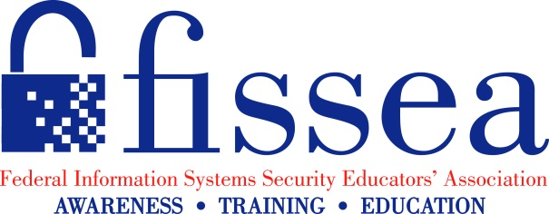
Call for Presentations

FISSEA 30th Annual Conference

March 14 - 15, 2017

National Institute of Standards and Technology, Gaithersburg, Maryland

Securing the Future to Infinity and Beyond: 30 years of Improving Cybersecurity through Awareness, Training, and Education

NOW ACCEPTING SUBMISSIONS

FISSEA is seeking presentations for the 2017 Annual Conference. Join us for our 30th year anniversary and share your expertise and creative ideas with a highly motivated professional audience from government, industry, and academia. We encourage you to address all aspects of information security but to focus on the awareness and training aspect.

Topics of interest:
The Federal Information Systems Security Educators' Association (FISSEA), founded in 1987, is an organization run by and for information systems security professionals to assist federal agencies in meeting their information systems security awareness, training, education, and certification responsibilities.

- FISSEA Core issues – Awareness, Training, Education, Certification
- New Techniques for Developing and Conducting Effective, Meaningful Training
- Gamification – how has a game made a difference in your program
- Cyber competitions – how can competitions play into security training
- How to adapt training and engage Millennials, Gen X, & Baby Boomers (multigenerational workforce)
- Cybersecurity Governance
- Beat the breaches – how do you deal with it
- Cost- Effective Practices
- How to take technical training topics and implement it into an OPM business case
- Building an Insider Threat program
- How to get leadership buy-in for cybersecurity programs
- Skillset Gaps – how to increase knowledge of the cybersecurity workforce
- Free Resources, Awareness Ideas – What’s Available
- What makes a good awareness program – what makes good training- online vs. classroom – what engages people, how do you evaluate, what is the benchmark
- Effective anti-phishing strategies/exercises
- Proper use of email/records management - Privacy
- Role-based Training
- Where do you generate your training ideas and get subject matter experts
- Lessons Learned and best practices
- Where do you see security training evolving to - ideas for the future

FISSEA invites proposals for Panel Discussions, Topic Sessions, and the Pecha Kucha (Lightning Round).
Please keep in mind that sessions are not marketing opportunities, thus corporate marketing materials are not permitted during the sessions.

Submission Deadline: January 5, 2017

Email submission form to fissea2017call@nist.gov
FISSEA website: http://csrc.nist.gov/fissea
Submission Form for Proposed Presentation

FISSEA 2017 Conference

Please Note: FISSEA is seeking speaker presentations (i.e., not papers). If you submit a proposal, we will assume that you will be available to present on March 14th or 15th. Generally, topic sessions, including Q&A, are 25 minutes, while panel discussions are 50 minutes. Pecha Kucha means “chit chat” in Japanese. We use the term to describe a session that contains a series of rapid-paced slides (20 slides are shown for 20 seconds each for a total of 6 minutes, 40 seconds.)

[Note: Please submit a separate form if you would like to submit more than one presentation.]

Name:

Title:

Organization:

Email Address:

Mailing Address:

Phone (Work): Phone (Cell):

Title of Presentation:

Type: [ ] Panel Discussion [ ] Topic Session [ ] Pecha Kucha Session (Lightning Round)
Length of Time Needed ____

Synopsis/Overview (100-250 words to be used by the selection committee and in the conference program).

Level of Discussion (Introductory/Intermediate/Advanced):

Desired Learning Outcomes:

Directions for Submission

Email Submission Form for Proposed Presentation to: fissea2017call@nist.gov

All submissions must be in Microsoft Word.
The subject line for the email should be
“FISSEA 2017 Conference – Submission Form for Proposed Presentation”

Remember the January 5th Submission Deadline!

Direct contacts: Clarence Williams clarence.williams@nist.gov or Peggy Himes (peggy.himes@nist.gov)

