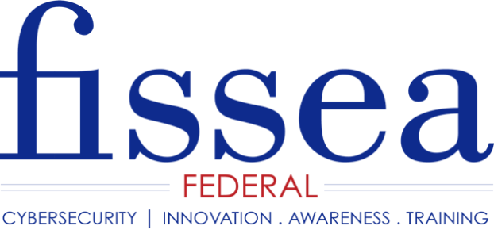

FISSEA Security Awareness and Training Contest

Entry Form
Please review rules before completing entry form including the due date. No late entries will be accepted. E-mail entries to fissea-contest@nist.gov.

Name of submitter: _______________________________________________

Organization: ____________________________________________________

Name and/or Organization to be listed on the award certificate if the entry wins:

________________________________________________________________

Address: ________________________________________________________

________________________________________________________________

Phone: _________________________________________________________

Email Address: __________________________________________________

Type of Entry (Please list the entry type on the line provided or circle or highlight it in the list of options below):

Awareness: there are SEVEN categories in this area: Poster, Motivational Item, Website, Newsletter, video (please limit to 5 min or less), Cybersecurity Blog, Cybersecurity Podcast.

Training: there is one category for this area: Interactive scenario/exercise

___________________________________________________________

Title of Entry: ____________________________________________________

Description of Entry (please limit to 250 words):

________________________________________________________________

