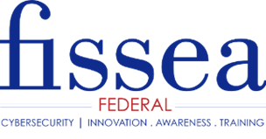

FISSEA 2020 CYBERSECURITY AWARENESS AND TRAINING INNOVATOR AWARD
Nomination form

Please review the nomination information, including the due date, provided on
the FISSEA website before completing the form.

Name of Nominee:

Employing Organization:

Position and/or Title:

Nominee’s Phone Number:

Nominee’s E-mail Address: ______________________________

Qualifications Statement: (What has the nominee done to warrant this nomination?)

I nominate (full name and title) of (organization) for the FISSEA 2020 Cybersecurity Awareness and Training Innovator Award.

Explain how the nominee exemplified innovation in an awareness and training program and the impact of the program.

Explain how the public sector benefited from the activities of the nominee.

Describe the impact of the nominee’s achievements and accomplishments within and/or beyond the nominee's organization?

If any of the activities of the nominee were part of a group effort, indicate amount and type of direct participation by the nominee as compared to other participants. Describe how the nominee distinguished him/herself from other members of the group.

FISSEA should consider this additional information about the nominee:

(Person making this nomination) (Date) (Daytime Phone Number)

__________________________________________
(Person making this nomination e-mail address)

